Current Process



## Specification

#### **Generate VAT Report**

Every month the accounting area downloads an excel file called VAT Report from FxClient. This file has a structure detailed in Appendix A and contains all the transactions got from Oxonine as consider for the Accounting System. The data has accepted orders and cancelled orders. The accepted order tax rows have a negative value and the cancelled order tax rows has a positive value. This report file is the source to continue with the next activities (VAT Report).

#### **Build VAT Summary**

Accounting area summarizes all information provided from VAT Report and calculates the tax amounts which are accepted orders and cancelled orders. The accepted orders are whose amounts are negative and will be the pivot to match with sales tickets in the next activities.

The cancelled orders, which are those amounts are positive, will be summarized to calculate a total amount and will be used to generate credit notes when the process is finished.

The result of this activity is to get two types of information (accepted and cancelled amounts) and the information to extract from this VAT Report are: document type (39 for ST or Boletas and 61 for Credit Notes), tax amount and date. The file generated in this step is stored as VAT Summary.

#### **Download Sales Tickets**

This activity consists of to download from GDExpress all sales tickets in the target month and all tickets will be stored in a temporary Database.

#### **Get Differences between VAT and ST**

This activity will get all differences between both sources i.e. VAT and ST. The following differences will be calculated (in detail and in summary):

1. All the ST which are in VAT Report and are in GDExpress, these data include the ST from cancelled orders (C).
2. All the ST which are in GDExpress but are not in VAT Report, these data are orders from cancelled orders before to be sent to post in FxOnline.
3. All the ST which are in VAT Report but are not in GDExpress, these are orders which do not have a ST generated in GDExpress.

These information is represented by the following diagram:



#### **Elaborate Summary Conciliation Report**

This step uses the information calculated in the previous step to elaborate a summary which represents the conciliation process. This summary Excel file has the following layout and will be sent to Accounting:

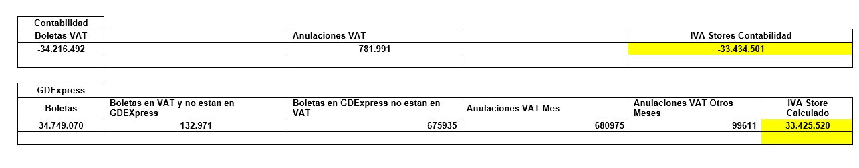

This report consists of two parts: the above part has the accounting information provided by the VAT Report originally. These amounts are calculated from the transaction details in the file. The first amount is the total amount, the second are the cancelled orders after to post the orders in FxOnline and the third amount is the difference between the previous amount mentioned above.

The other part of this layout shows the information from GDExpress where the first amount is the total amount of taxes registered in this source. The second column is the total amount of taxes which are in VAT Report but are not in GDExpress (the main reason is missing documents on GDExpress after the order was generated in FxOnline because the tax receipt generation is a manual process and the cashier might not have generated the document using the store tax application). The third column is the total tax amount which are not in VAT Report (because the orders were cancelled before to post them). The fourth column is the total amount of taxes from cancelled orders in VAT in the same month. The fifth column is the total amount of taxes from cancelled orders in VAT which were generated in different months than the considered target month. And finally, the sixth column is the subtraction of the 3nd, 4th, 5th columns from the total amount of taxes registered in the first column and adding the 2nd column. Cells highlighted with yellow in both parts of layout are being approximately equal. In this sample, there is a slight difference of 8981 CLP which could be rounding differences.

The conciliation report will balance the information provided by GDExpress and the information from VAT Report using the previous information and the following equation:

**G + (3) – (2) – [C] <=> VAT – [C]**

Where:

* G: Sales Tickets Tax Total Amount from GDExpress.
* (3): Sales Tickets Tax Total Amount which are in VAT Report but are not in GDExpress.
* (2): Sales Tickets Tax Total Amount which are in GDExpress but are not in VAT Report.
* [C]: Sales Tickets Tax Total Amount from cancelled orders.
* VAT: Sales Tickets Tax Total Amount from VAT Report.

The left-hand expression will never be equal to the right hand express because of rounding issues. For example, each tax amount could be rounded with 1 digit and if there are 57 000 transactions then the total amount by each amount rounded will be possibly 57 000 CLP. We realize in the layout shown above that there is 8 000 CLP. There is a sensitivity amount to be considered by Accounting but we do not know which amount will be considered as a minimum difference.

#### **Consolidate VAT Report**

This activity is responsibility of Accounting area and consists of to upload the Summary Conciliation Report to FxClient.

The accounting will consider to make other task to conciliate after all this process but it is internal and not to be considered in this process diagram.

# **Proposed**



## Specification

#### **Generate VAT Report**

Get the information for VAT Report using FxOnline Database.

#### **Build VAT Summary**

Generate a summary information for data captured from FxOnline Database but using the format described in the current process.

#### **Download Sales Tickets**

Using the GDExpress, the system will download all the documents in the current period.

#### **Get Differences between VAT and ST**

The system calculates the differences between information generated in GDExpress and Information originated in FxOnline Database so it is necessary exploit this information per current process described.

#### **Elaborate Summary Conciliation Report**

The report will keep the current information and format and will be send by e-mail to Accounting.

#### **Consolidate VAT Report**

It is necessary to update the input VAT Report to generate missing invoices or generate credit notes per found differences.